**SMART STAR EXAMINATIONS BOARD**

**END OF TERM ONE EXAMINATION - 2024**

**READING**

**BABY CLASS**

My name is………………………………………

1. **Tell the sounds.**

a s t

1. **Shade S and the friend.**

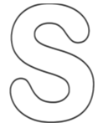 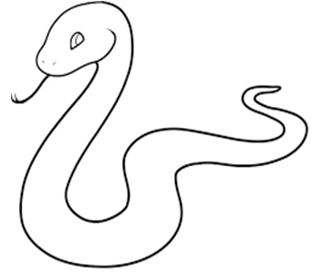

1. 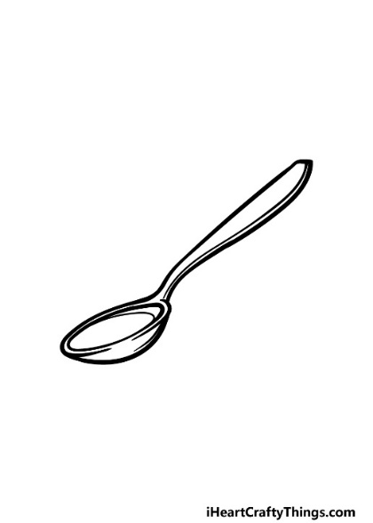**Match the same.**

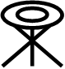

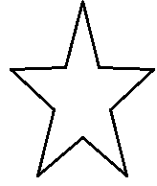





1. **Trace sound a and the friend.**

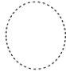

Oral.

1. A cow says……………..

A cat says ……………. END: